DAY 10 - C/C++ PROGRAMMING - HARSHINIE M

/*
Purpose : To demonstrate the use of command-line arguments in C
by displaying the argument count (argc) and argument
vector (argv) passed to the program.
Question: Write a C program to display the count of command-line
arguments and print each argument with its index.
Author : Harshinie M
Date : 05/01/2026
*/

#include <stdio.h>

int main(int argc, char *argv[]){

printf("Count of args: %d\n", argc);

printf("Argument List: \n");

for(int cnt = 0; cnt < argc; cnt++)

printf("\t\targv[%d] ==> %s\n", cnt, argv[cnt]);

}

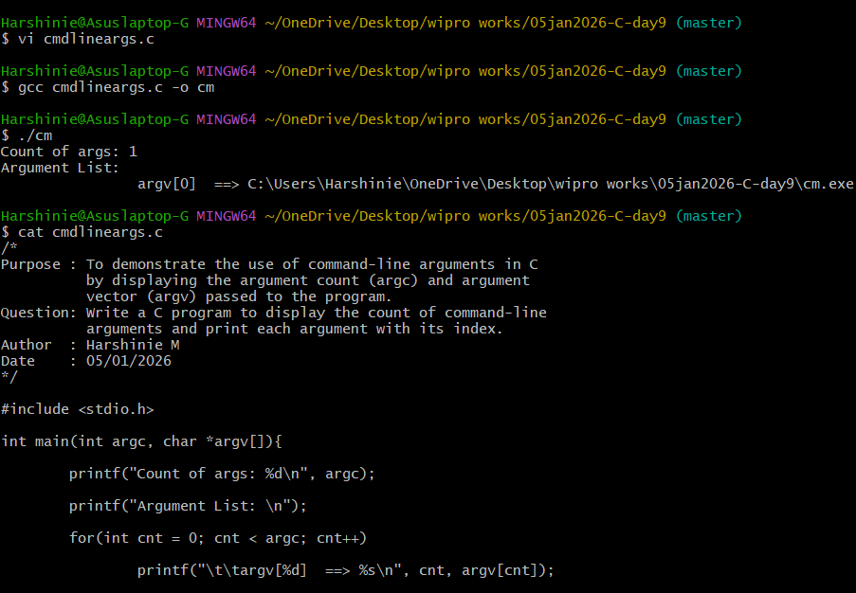

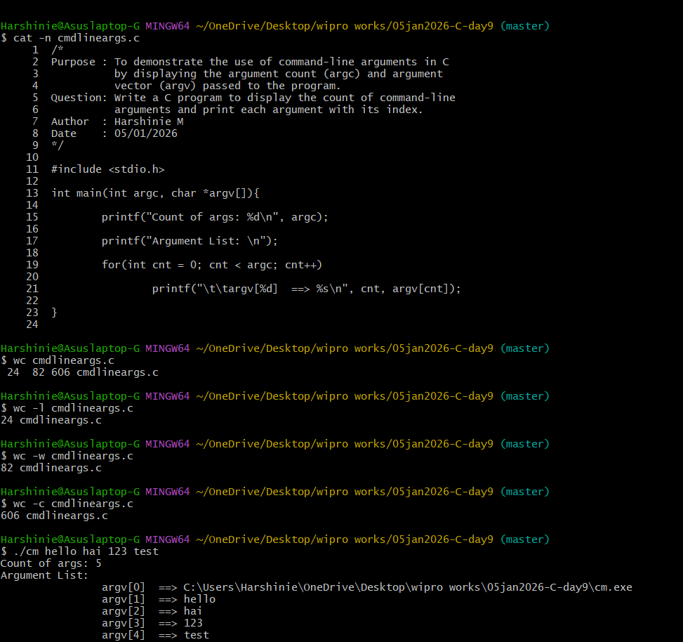

ioThree.cpp

#include <iostream>
using namespace std;

int main() {
cout << "File I/O Example";
return 0;
}

/*
Purpose : To demonstrate reading a file word by word using
ifstream and the extraction (>>) operator.
Question: Write a C++ program to read the contents of a file
word by word and display them on the screen.
Author : Harshinie M
Date : 05/01/2026
*/

#include <iostream>
#include <fstream>
using namespace std;

int main(){
ifstream fobj("ioThree.cpp"); // Open file in read mode
string str;

while (fobj >> str) // Reads word by word
cout << str << " ";

fobj.close();
return 0;
}

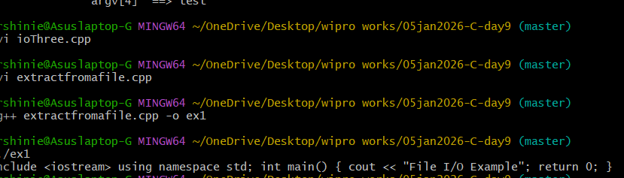

/*
Purpose : To demonstrate reading a file line by line using
ifstream and getline() function.
Question: Write a C++ program to read the contents of a file
line by line and display them on the screen.
Author : Harshinie M
Date : 05/01/2026
*/

#include <iostream>
#include <fstream>
using namespace std;

int main(){
ifstream fobj("ioThree.cpp"); // Open file in read mode
string str;

while (getline(fobj, str)) // Reads line by line
cout << str << endl;

fobj.close();
return 0;
}

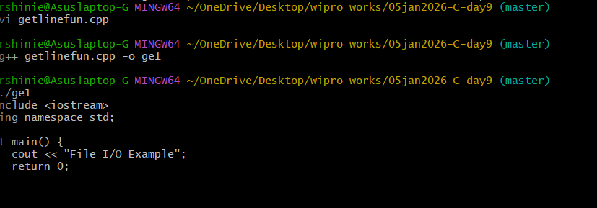

/*
Purpose : To demonstrate writing an object of a class into a
binary file using ofstream in C++.
Question: Write a C++ program to store an Employee object in a
binary file using write() function.
Author : Harshinie M
Date : 05/01/2026
*/

#include <iostream>
#include <fstream>
#include <cstring>
using namespace std;

class Employee{
int id;
char name[40];
double sal;

public:
Employee(int num = 1001, const char *na = "Sample #1", double sa = 15000.05)
: id(num), sal(sa) {
strcpy(name, na);
}

void disp(){
cout << "Output Num: " << id
<< "\tName: " << name
<< "\tSal: " << sal << endl;
}
};

int main(){
Employee emps = Employee(1101, "Karthik", 15000.45);

ofstream fObj("myData.dat", ios::binary); // Open binary file

fObj.write((char*)&emps, sizeof(emps)); // Write object to file

emps.disp(); // Display object data

fObj.close();
return 0;
}
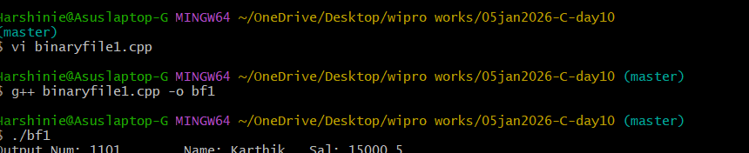

/*
Purpose : To demonstrate reading an object of a class from a
binary file using ifstream in C++.
Question: Write a C++ program to read an Employee object from a
binary file and display its contents.
Author : Harshinie M
Date : 05/01/2026
*/

#include <iostream>
#include <cstring>
#include <fstream>
using namespace std;

class Employee{
int id;
char name[40];
double sal;

public:
Employee(int num = 1001, const char *na = "Sample #1", double sa = 15000.05)
: id(num), sal(sa) {
strcpy(name, na);
}

void disp(){
cout << "Output Num: " << id
<< "\tName: " << name
<< "\tSal: " << sal << endl;
}
};

int main(){
Employee emps; // Object with default values

emps.disp(); // Display default values

ifstream fObj("myData.dat", ios::binary); // Open binary file

if (fObj){
fObj.read((char*)&emps, sizeof(emps)); // Read object from file
emps.disp(); // Display read values
}

fObj.close();
return 0;
}
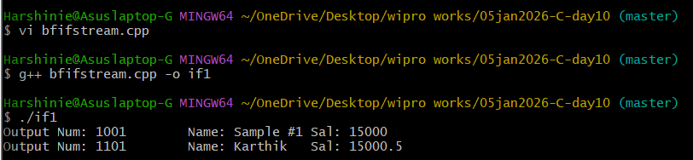

ioOne.cpp
#include <iostream>
using namespace std;

int main() {
cout << "Hello File I O";
return 0;
}

/*
Purpose : Implement your own cat program, which will take file name
as an argument and print the contents of the file on the screen.
Author : Harshinie M
Date : 05/01/2026
*/

#include <iostream>
#include <fstream>
using namespace std;

int main(int argc, char *argv[]){
ifstream fin(argv[1]);
string line;

while (getline(fin, line))
cout << line << endl;

fin.close();
return 0;
}

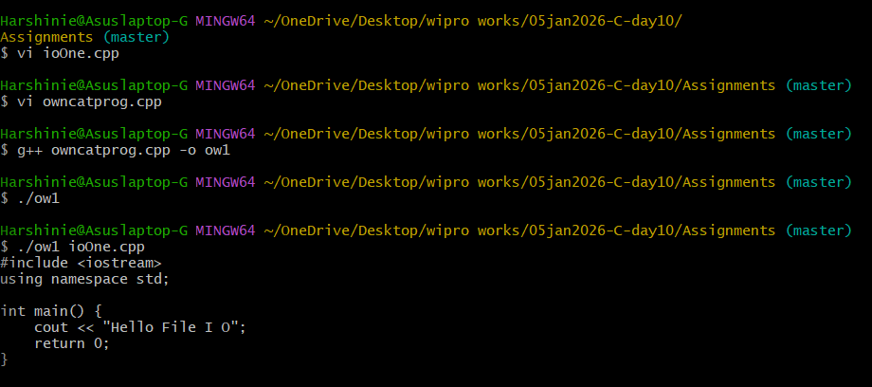

/*
Purpose : Update your own cat program, which will take -n option and
file name as arguments and print the contents of the file
on the screen along with the line numbers.
Author : Harshinie M
Date : 05/01/2026
*/

#include <iostream>
#include <fstream>
using namespace std;

int main(int argc, char *argv[]){
ifstream fin(argv[2]);
string line;
int lineNo = 1;

while (getline(fin, line)){
cout << lineNo << " " << line << endl;
lineNo++;
}

fin.close();
return 0;
}

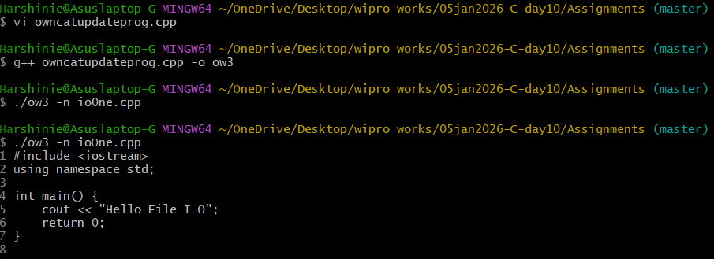
/*
Purpose : Implement your wc program, which takes in file name as an
argument and print number of lines, number of words and
number of characters present in the file along with the file name.
Author : Harshinie M
Date : 05/01/2026
*/

#include <iostream>
#include <fstream>
#include <sstream>
using namespace std;

int main(int argc, char *argv[]){
ifstream fin(argv[1]);
string line, word;
int lines = 0, words = 0, chars = 0;

while (getline(fin, line)){
lines++;
chars += line.length() + 1;

stringstream ss(line);
while (ss >> word)
words++;
}

cout << lines << " " << words << " " << chars << " " << argv[1] << endl;

fin.close();
return 0;
}

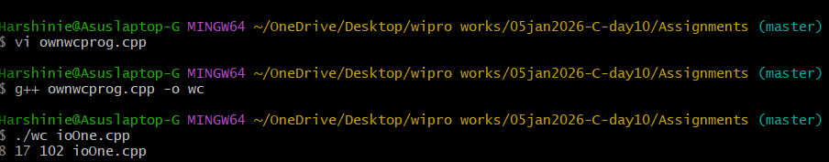

dataTest.txt
Hello World

/*
Purpose : Demonstrate the use of tellp() to show the position of the
file write pointer while writing data into a file.
Author : Harshinie M
Date : 05/01/2026
*/

#include <iostream>
#include <fstream>
using namespace std;

int main() {
ofstream fout("dataTest.txt");

cout << "Initial position: " << fout.tellp() << endl;

fout << "Hello";
cout << "After writing 'Hello': " << fout.tellp() << endl;

fout << " World";
cout << "After writing ' World': " << fout.tellp() << endl;

fout.close();
return 0;
}

